Lab: 3a_lab_A
Student Deliverables
03/09/2026
Name: Jorune Simpkins
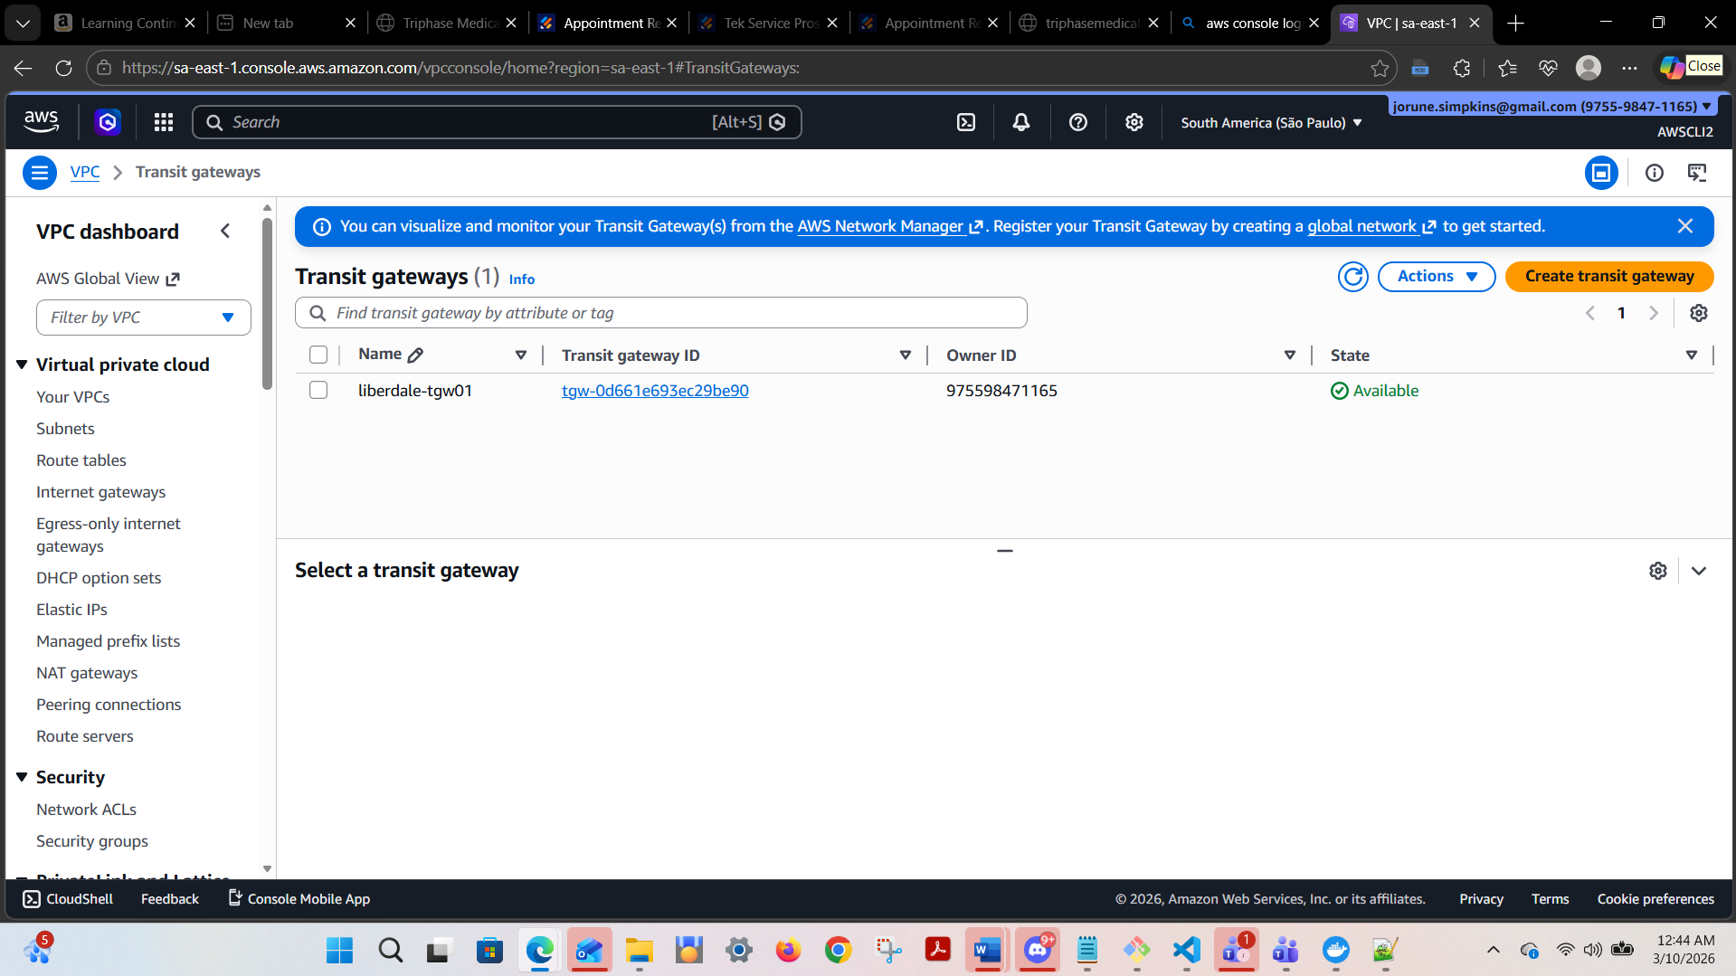

Confirm routes (AWS CLI)
For each region, verify route tables include the cross-region CIDR to TGW:

aws ec2 describe-route-tables --filters "Name=vpc-id,Values=<VPC_ID>" --query "RouteTables[].Routes[]"
Sao_Paulo:
jorun@Simpkij3421 MINGW64 /c/users/jorun/documents/theowaf/armageddon/armageddon_repo/armageddon_clone/3a_lab_au/sao_paulo_files (main)

$ aws ec2 describe-route-tables --filters "Name=vpc-id,Values=vpc-022d7725ee614352b" --query "RouteTables[].Routes[]"
[]

aws ec2 describe-route-tables --filters "Name=vpc-id,Values=<VPC_ID>" --query "RouteTables[].Routes[]"
jorun@Simpkij3421 MINGW64 /c/users/jorun/documents/theowaf/armageddon/armageddon_repo/armageddon_clone/3a_lab_au/tokyo_files (main)
$ aws ec2 describe-route-tables --filters "Name=vpc-id,Values=vpc-0eab03b92b64f47e5" --query "RouteTables[].Routes[]"
[]

Tokyo Output:
Outputs:

alb_dns_name = "shinjuku-final-alb01-2142099596.ap-northeast-1.elb.amazonaws.com"
alb_sg_id = "sg-0db15577b96855e2a"
cloudfront_distribution_id = "E245PRDE0X0ZBS"
shinjuku_alb_logs_bucket_name = "shinjuku-final-alb-logs-975598471165"
shinjuku_apex_url_https = "https://firstpointand.click"
shinjuku_app_url_https = "https://app.firstpointand.click"
shinjuku_ec2_instance_id = "i-0128fcc4e13f2589e"
shinjuku_log_group_name = "/aws/ec2/shinjuku-final-rds-app"
shinjuku_origin_header_value = <sensitive>
shinjuku_private_subnet_ids = [
"subnet-04de1112195ba9d94",
"subnet-07c2c51aa13f30537",
]
shinjuku_public_subnet_ids = [
"subnet-09714981415f217f7",
"subnet-052e8d0e6e82e578a",
]
shinjuku_rds_endpoint = "shinjuku-final-rds01.cf2s8kkgau9w.ap-northeast-1.rds.amazonaws.com"
shinjuku_rds_port = 3306
shinjuku_route53_zone_id = "Z0577510JJCMGIYZ7086"
shinjuku_sns_topic_arn = "arn:aws:sns:ap-northeast-1:975598471165:shinjuku-final-db-incidents"
shinjuku_vpc_id = "vpc-0eab03b92b64f47e5"
shinjuku_waf_log_destination = "cloudwatch"
target_group_arn = "arn:aws:elasticloadbalancing:ap-northeast-1:975598471165:targetgroup/shinjuku-final-tg01/c3c3beff37ca1a9c"
tokyo_tgw_id = "tgw-03318e02dcb7e06bb"
tokyo_tgw_peering_attachment_id = "tgw-attach-0757d6d3816e1ca21"
tokyo_vpc_cidr = "10.100.0.0/16"

SaoPaulo Output:
Outputs:

alb_dns_name = "liberdade-final-alb01-1255017430.sa-east-1.elb.amazonaws.com"
alb_sg_id = "sg-0688885ec9cced3dd"
liberdale_alb_logs_bucket_name = "liberdade-final-alb-logs-975598471165"
liberdale_apex_url_https = "https://firstpointand.click"
liberdale_app_url_https = "https://app.firstpointand.click"
liberdale_ec2_instance_id = "i-0eefcf350e1da8302"
liberdale_log_group_name = "/aws/ec2/liberdade-final-rds-app"
liberdale_origin_header_value = <sensitive>
liberdale_private_subnet_ids = [
"subnet-094977984a932f3a3",
"subnet-063b5032490e5f34b",
]
liberdale_public_subnet_ids = [
"subnet-003b59ef8b0a297d9",
"subnet-0177abded16efe23e",
]
liberdale_sns_topic_arn = "arn:aws:sns:sa-east-1:975598471165:liberdade-final-db-incidents"
liberdale_vpc_id = "vpc-022d7725ee614352b"
liberdale_waf_log_destination = "cloudwatch"
saopaulo_tgw_id = "tgw-0d661e693ec29be90"
saopaulo_vpc_cidr = "10.200.0.0/16"
target_group_arn = "arn:aws:elasticloadbalancing:sa-east-1:975598471165:targetgroup/liberdade-final-tg01/58e246473f7fe6d6"
tokyo_rds_endpoint_in_use = "shinjuku-final-rds01.cf2s8kkgau9w.ap-northeast-1.rds.amazonaws.com"

outputs.tf in Tokyo exports:
tokyo_vpc_cidr:
tokyo_vpc_cidr = "10.100.0.0/16"

tokyo_tgw_id:
tokyo_tgw_id = "tgw-03318e02dcb7e06bb"

tokyo_rds_endpoint:
shinjuku_rds_endpoint = "shinjuku-final-rds01.cf2s8kkgau9w.ap-northeast-1.rds.amazonaws.com"
Apply complete! Resources: 9 added, 2 changed, 0 destroyed.

Outputs:
Sao_Paulo
alb_dns_name = "liberdade-final-alb01-1255017430.sa-east-1.elb.amazonaws.com"
alb_sg_id = "sg-0688885ec9cced3dd"
liberdale_alb_logs_bucket_name = "liberdade-final-alb-logs-975598471165"
liberdale_apex_url_https = "https://firstpointand.click"
liberdale_app_url_https = "https://app.firstpointand.click"
liberdale_ec2_instance_id = "i-0eefcf350e1da8302"
liberdale_log_group_name = "/aws/ec2/liberdade-final-rds-app"
liberdale_origin_header_value = <sensitive>
liberdale_private_subnet_ids = [
"subnet-094977984a932f3a3",
"subnet-063b5032490e5f34b",
]
liberdale_public_subnet_ids = [
"subnet-003b59ef8b0a297d9",
"subnet-0177abded16efe23e",

liberdale_sns_topic_arn = "arn:aws:sns:sa-east-1:975598471165:liberdade-final-db-incidents"
liberdale_vpc_id = "vpc-022d7725ee614352b"
liberdale_waf_log_destination = "cloudwatch"
saopaulo_tgw_id = "tgw-0d661e693ec29be90"
saopaulo_vpc_cidr = "10.200.0.0/16"
target_group_arn = "arn:aws:elasticloadbalancing:sa-east-1:975598471165:targetgroup/liberdade-final-tg01/58e246473f7fe6d6"
tokyo_rds_endpoint_in_use = "shinjuku-final-rds01.cf2s8kkgau9w.ap-northeast-1.rds.amazonaws.com"

jorun@Simpkij3421 MINGW64 /c/users/jorun/documents/theowaf/armageddon/armageddon_repo/armageddon_clone/3a_lab_au/sao_paulo_files (main)

OUTPUTS:
cd saopaulo/
terraform apply \
-var="tokyo_tgw_peering_attachment_id=tgw-attach-0757d6d3816e1ca21" \
-var="tokyo_rds_endpoint=shinjuku-final-rds01.cf2s8kkgau9w.ap-northeast-1.rds.amazonaws.com" \
-var="tokyo_cloudfront_domain_name=d3ccuk0gv0dfex.cloudfront.net"

After this, go to AWS Console → VPC → Transit Gateway Peering Attachments in sa-east-1 and confirm status is Available.

nc -vz <tokyo-rds-endpoint> 3306

nc -vz shinjuku-final-rds01.cf2s8kkgau9w.ap-northeast-1.rds.amazonaws.com 3306

Confirm routes (AWS CLI)
For each region, verify route tables include the cross-region CIDR to TGW:

aws ec2 describe-route-tables --filters "Name=vpc-id,Values=vpc-022d7725ee614352b" --query "RouteTables[].Routes[]"

aws ec2 describe-route-tables --filters "Name=vpc-id,Values=vpc-0eab03b92b64f47e5" --query "RouteTables[].Routes[]"

shinjuku_vpc_id = "vpc-0eab03b92b64f47e5"

1) How should São Paulo Terraform change once TGW is established?

"ready for Lab 3B"

Find: Grand marquis 2007 124000 millas
$5,000

aws s3 rm s3://liberdade-final-alb-logs-975598471165 --recursive --region sa-east-1
aws s3 rm s3://shinjuku-final-alb-logs-975598471165 --recursive --region ap-northeast-1

liberdale_vpc_id = "vpc-022d7725ee614352b"

Explain in 8–12 lines: “Why this design is safe from an APPI perspective, and why the DB cannot be placed overseas.”

___________________________________________________________
03/10/2026

Note: To get to this point: RUN terraform init -> terraform validate -> terraform plan -> terraform apply -target=aws_ec2_transit_gateway.liberdale_tgw01 (NOT just terraform apply -> not yet for the full apply)

sao_paulo:
saopaulo_tgw_id = "tgw-0d0c0b7910d303ec9"

Tokyo 03/10/2026:
terraform apply -var="saopaulo_tgw_id=tgw-0d0c0b7910d303ec9"

tokyo_tgw_peering_attachment_id = "tgw-attach-0c0ed468e648d69ac"
shinjuku_rds_endpoint = "shinjuku-final-rds01.cf2s8kkgau9w.ap-northeast-1.rds.amazonaws.com"
cloudfront_domain_name = "d1kucxetkz0k22.cloudfront.net"
tokyo_vpc_cidr = "10.100.0.0/16"
tokyo_tgw_id = "tgw-0546835d2d5f45b3c"

Tokyo 03/10/2026:
Outputs:

alb_dns_name = "shinjuku-final-alb01-457019929.ap-northeast-1.elb.amazonaws.com"
alb_sg_id = "sg-06780e892fac4c19d"
cloudfront_distribution_id = "E3QGZWEEDVD25N"
shinjuku_alb_logs_bucket_name = "shinjuku-final-alb-logs-975598471165"
shinjuku_apex_url_https = "https://firstpointand.click"
shinjuku_app_url_https = "https://app.firstpointand.click"
shinjuku_ec2_instance_id = "i-05c7ffbcf2ff75090"
shinjuku_log_group_name = "/aws/ec2/shinjuku-final-rds-app"
shinjuku_origin_header_value = <sensitive>
shinjuku_private_subnet_ids = [
"subnet-0d5129e6bdc92d68f",
"subnet-0fafdf0f44b96593a",
]
shinjuku_public_subnet_ids = [
"subnet-0baf10c89dc09a304",
"subnet-0a3ca6960d5d595f0",
]
shinjuku_rds_endpoint = "shinjuku-final-rds01.cf2s8kkgau9w.ap-northeast-1.rds.amazonaws.com"
shinjuku_rds_port = 3306
shinjuku_route53_zone_id = "Z0577510JJCMGIYZ7086"
shinjuku_sns_topic_arn = "arn:aws:sns:ap-northeast-1:975598471165:shinjuku-final-db-incidents"
shinjuku_vpc_id = "vpc-07d13b089c6d602f6"
shinjuku_waf_log_destination = "cloudwatch"
target_group_arn = "arn:aws:elasticloadbalancing:ap-northeast-1:975598471165:targetgroup/shinjuku-final-tg01/6f48be9e9c988e4e"
tokyo_tgw_id = "tgw-0546835d2d5f45b3c"
tokyo_tgw_peering_attachment_id = "tgw-attach-0c0ed468e648d69ac"
tokyo_vpc_cidr = "10.100.0.0/16"

jorun@Simpkij3421 MINGW64 /c/users/jorun/documents/theowaf/armageddon/armageddon_repo/armageddon_clone/3a_lab_au/tokyo_files (main)
$ aws cloudfront list-distributions \
--query "DistributionList.Items[*].{ID:Id,Domain:DomainName}" \
--output table --region us-east-1
-----------------------------------------------------
| ListDistributions |
+--------------------------------+------------------+
| Domain | ID |
+--------------------------------+------------------+
| d2bk61akfzap4b.cloudfront.net | E18ZG1CDXH524N |
| d1kucxetkz0k22.cloudfront.net | E3QGZWEEDVD25N |
+--------------------------------+------------------+

Go to sao_paulo and run:
cd saopaulo/
terraform apply \
-var="tokyo_tgw_peering_attachment_id=tgw-attach-0c0ed468e648d69ac" \
-var="tokyo_rds_endpoint=shinjuku-final-rds01.cf2s8kkgau9w.ap-northeast-1.rds.amazonaws.com" \
-var="tokyo_cloudfront_domain_name=d1kucxetkz0k22.cloudfront.net"

sao_paulo
Outputs:

alb_dns_name = "liberdade-final-alb01-33980114.sa-east-1.elb.amazonaws.com"
alb_sg_id = "sg-0f6806fa1f4c027fc"
liberdale_alb_logs_bucket_name = "liberdade-final-alb-logs-975598471165"
liberdale_apex_url_https = "https://firstpointand.click"
liberdale_app_url_https = "https://app.firstpointand.click"
liberdale_ec2_instance_id = "i-018d26212130af454"
liberdale_log_group_name = "/aws/ec2/liberdade-final-rds-app"
liberdale_origin_header_value = <sensitive>
liberdale_private_subnet_ids = [
"subnet-092d6477d46401236",
"subnet-0460c704de27a7bec",
]
liberdale_public_subnet_ids = [
"subnet-06d0eb5f72f752835",
"subnet-0e3fb7e0b90e543f3",
]
liberdale_sns_topic_arn = "arn:aws:sns:sa-east-1:975598471165:liberdade-final-db-incidents"
liberdale_vpc_id = "vpc-0efae25c19f0307fb"
liberdale_waf_log_destination = "cloudwatch"
saopaulo_tgw_id = "tgw-0d0c0b7910d303ec9"
saopaulo_vpc_cidr = "10.200.0.0/16"
target_group_arn = "arn:aws:elasticloadbalancing:sa-east-1:975598471165:targetgroup/liberdade-final-tg01/fb5fc94d53064955"
tokyo_rds_endpoint_in_use = "shinjuku-final-rds01.cf2s8kkgau9w.ap-northeast-1.rds.amazonaws.com"
______________________________________________________________________________
AWS Console → VPC → Transit Gateway Peering Attachments in both ap-northeast-1 and sa-east-1 to confirm status in each region:
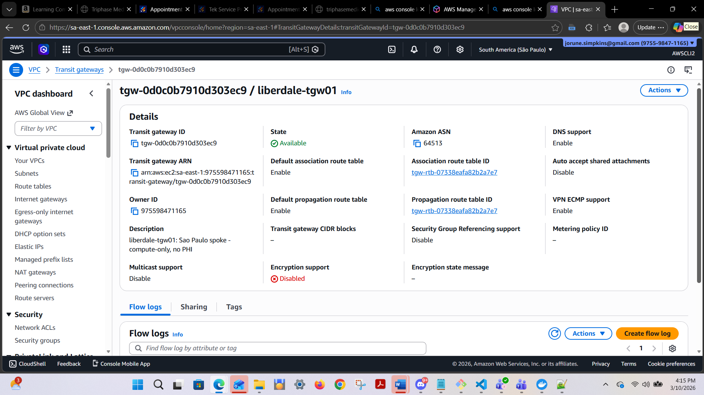

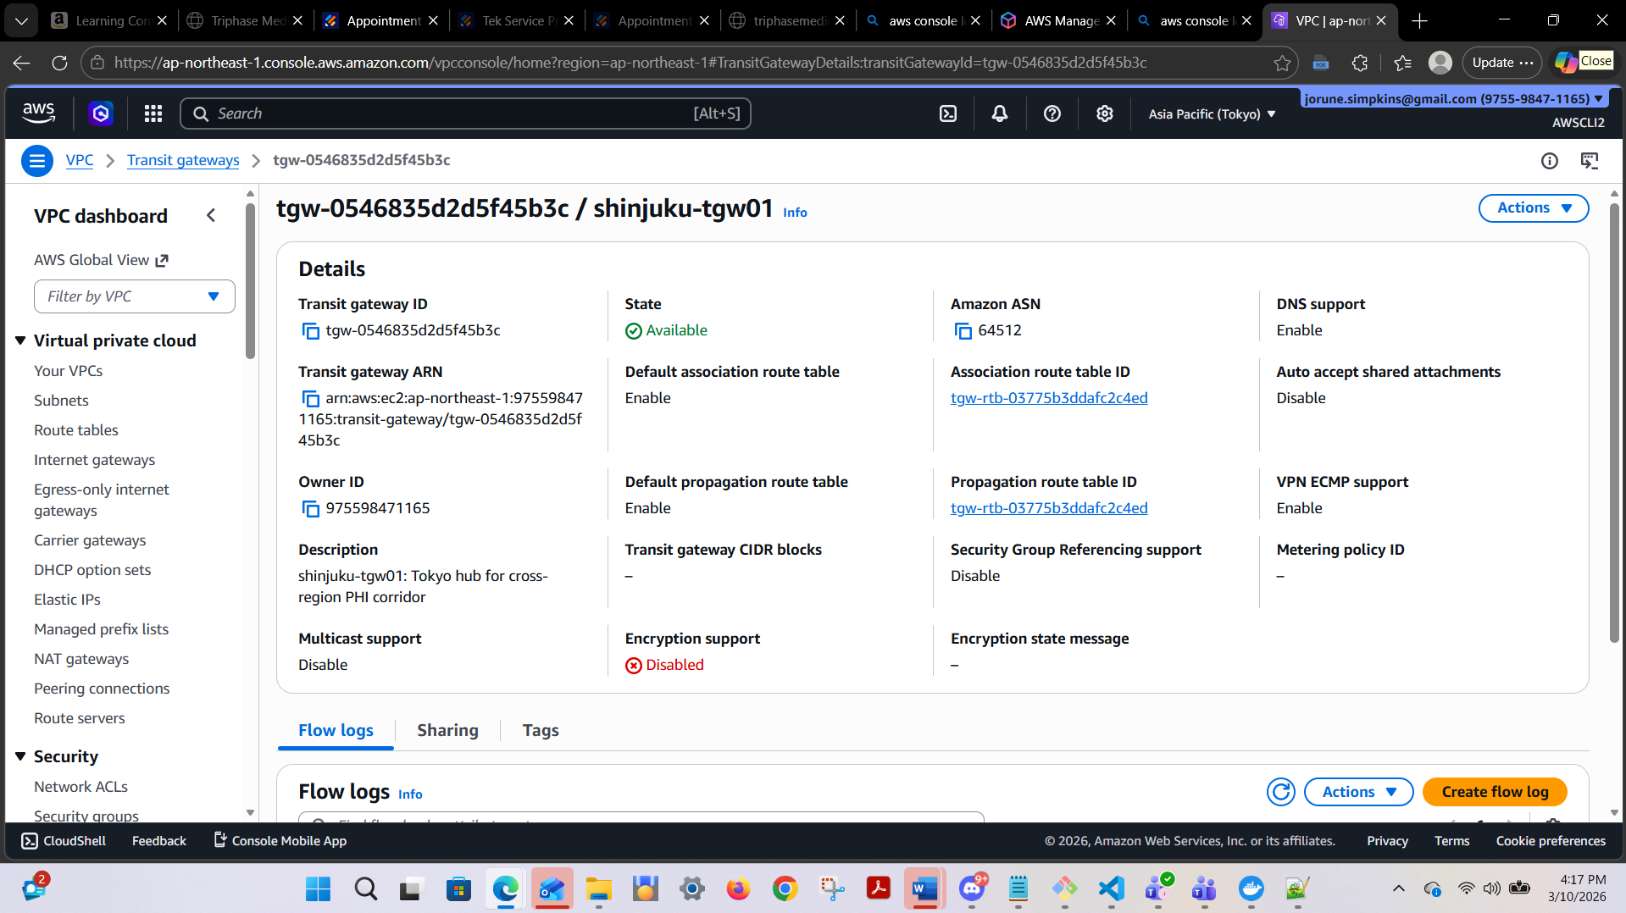

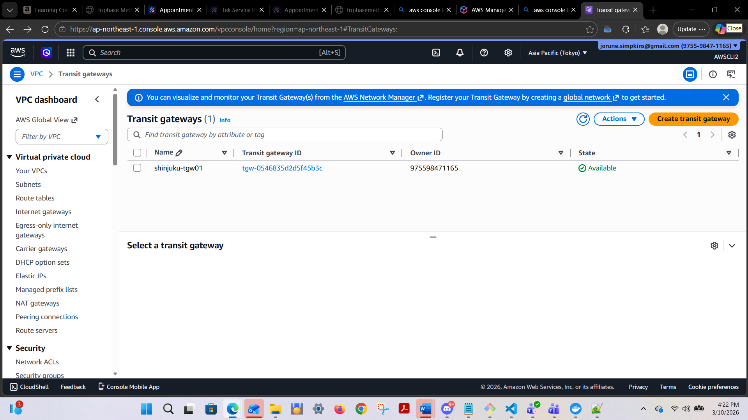

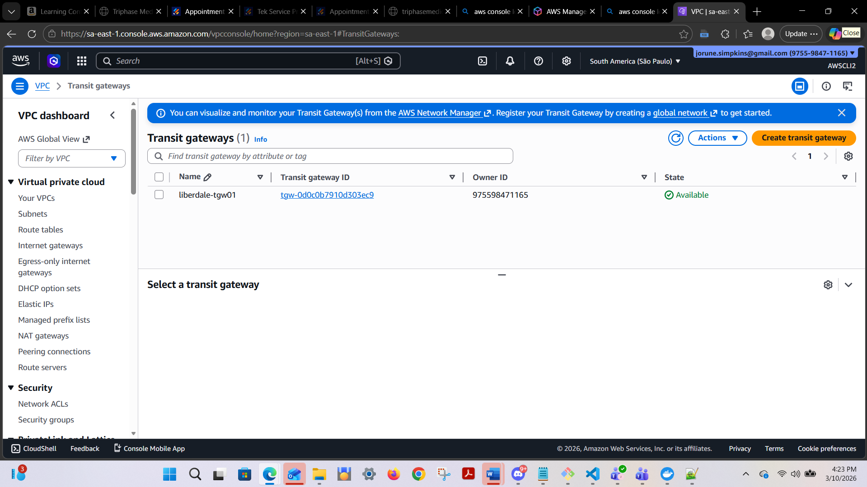

Tokyo:
terraform output tokyo_vpc_cidr:
tokyo_vpc_cidr = "10.100.0.0/16"

terraform output tokyo_tgw_id:
tokyo_tgw_id = "tgw-0546835d2d5f45b3c"

terraform output shinjuku_rds_endpoint:
shinjuku_rds_endpoint = "shinjuku-final-rds01.cf2s8kkgau9w.ap-northeast-1.rds.amazonaws.com"

jorun@Simpkij3421 MINGW64 /c/users/jorun/documents/theowaf/armageddon/armageddon_repo/armageddon_clone/3a_lab_au/tokyo_files (main)

Data Residency — RDS only in Tokyo
Confirm RDS exists in Tokyo:

$ aws rds describe-db-instances \
--region ap-northeast-1 \
--query "DBInstances[].{DB:DBInstanceIdentifier,AZ:AvailabilityZone,Endpoint:Endpoint.Address}" \
--output table
------------------------------------------------------------------------------------
| DescribeDBInstances
|
+----------+-----------------------------------------------------------------------+
| AZ | ap-northeast-1c
|
| DB | shinjuku-final-rds01
|
| Endpoint| shinjuku-final-rds01.cf2s8kkgau9w.ap-northeast-1.rds.amazonaws.com |
+----------+-----------------------------------------------------------------------+

Confirm NO RDS in Sao Paulo (must return empty list []):
jorun@Simpkij3421 MINGW64 /c/users/jorun/documents/theowaf/armageddon/armageddon_repo/armageddon_clone/3a_lab_au/sao_paulo_files (main)
$ aws rds describe-db-instances \
--region sa-east-1 \
--query "DBInstances[].DBInstanceIdentifier" \
--output table

jorun@Simpkij3421 MINGW64 /c/users/jorun/documents/theowaf/armageddon/armageddon_repo/armageddon_clone/3a_lab_au/sao_paulo_files (main)
$
$ aws ssm start-session \
--target i-018d26212130af454 \
--region sa-east-1

Starting session with SessionId: AWSCLI4-bbta5gujuv5tanvl2nsrz44zce
sh-5.2$ nc -vz shinjuku-final-rds01.cf2s8kkgau9w.ap-northeast-1.rds.amazonaws.com 3306
Ncat: Version 7.93 ( https://nmap.org/ncat )
Ncat: TIMEOUT.
sh-5.2$ nc -vz shinjuku-final-rds01.cf2s8kkgau9w.ap-northeast-1.rds.amazonaws.com 3306
Ncat: Version 7.93 ( https://nmap.org/ncat )
Ncat: TIMEOUT.
sh-5.2$ nc -vz shinjuku-final-rds01.cf2s8kkgau9w.ap-northeast-1.rds.amazonaws.com 3306
Ncat: Version 7.93 ( https://nmap.org/ncat )
Ncat: TIMEOUT.
sh-5.2$

